Science 9 Mid-Term Test

Energy and Change & Investigating Scientifically

Name: _________________

Outcome | Pointer | Questions | Achieved?

Investigating Scientifically

Introduction
At the front of the room there is an experiment set up. There are four aluminium cans, one of which is plain, while the others are covered with various materials. The teacher fills each can with boiling water from a kettle, and records the temperature of the water in the cans. Measurements will be taken every minute for ten minutes.

- AIM: What do you think this experiment is designed to investigate?

______________________________________________________________________________________________________________________________________________________________________________________________________

- MATERIALS: What equipment is being used in this investigation?

__________________________________________________________________________________________________________________________________________________________________________________________________________________________________________________________________________________________________________________________________________

- RESULTS: Design and construct a table to record the results of this experiment

- METHOD: In this experiment, what is the dependent variable? (i.e. What is the variable we are measuring?
____________________________________________________________________

- ANALYSIS: How will you assess the effectiveness of the different insulative coverings?
______________________________________________________________________________________________________________________________________________________________________________________________________
Heat: How much do you know?
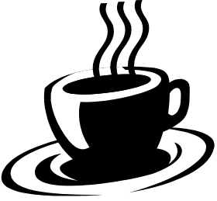

Name: _________________________

Try to use the following scientific words when you answer the questions below. If you can’t then use your own words:

Atoms | Energy | Heat | Conductor | Insulator
Reflect | Absorb | Conduction | Convection | Radiation
Thermometer | Expand | Contract | Vibrate | Float

- List two materials you used to make your thermos flask and say how each material helps keep the water hot inside the beakers. (Use words from the list)

  - Material 1:

How it helped keep the water hot:

  - Material 2:

How it helped keep the water hot:

□
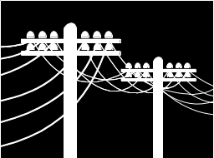
- Why do railway lines have gaps, power lines hang down and concrete driveways have rubber in gaps between sections? (Remember to try and use words from the list above)

□
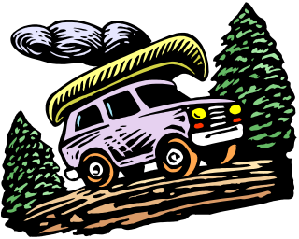
- White is the most common colour for cars sold in the northwest followed by silver then red then blue. How come? (Use words from the list)

□

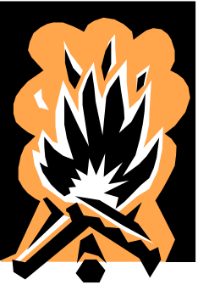
- A quick way to cook tinned food when camping is to put the tin directly in the fire. What should you do to make this safe? Why? (Try to use words from the list)

□

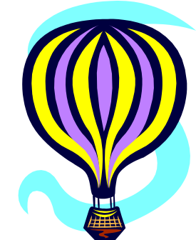
- Hot air balloons only contain hot air. How can they lift a heavy basket with two people inside. (Remember to use the words from the list)

□

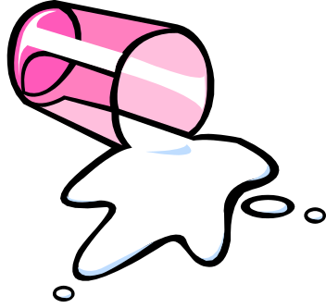
- Ice and water are made from the same stuff. Ice keeps its shape unless you break it. Water changes it shape depending on what container it is in. Explain why. (Try to use words from the list)

□


- List three design ideas to keep a Broome house as cool as possible without using electricity (air conditioners or fans)? Explain how each idea helps.

  - Idea 1:

How it keeps the house cool:

  - Idea 2:

How it keeps the house cool:

  - Idea 3:

How it keeps the house cool:

□

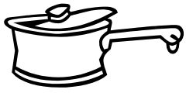
- Saucepans and frypans always have metal bases and usually have plastic or wooden handles. Why? (Try to use words from the list)

□

- Name three conductors and three insulators. (You will need to use your own words)

  - Conductors:

  - Insulators

□

Harder questions for experts

- Water in the pool feels cooler even though the water is the same temperature as the air. Why?

□

- Air conditioners in houses and classrooms usually have the vents that the cold air comes out of either high up in the wall or in the roof. Why are the vents always placed high up in a room and never near the floor?

□

- If someone were to throw boiling hot water on you, would you prefer a cupful of water or a bucketful of water? Why? (Try to use words from the list)

□

End of Assessment

Check your answers if you finished early. Good Luck.

